**HOW TO BUILD A GAMING COMPUTER**

This is a guide on building a computer considering that you already have all the parts ordered, and they are all compatible with each other.

A great way to do this is to visit pcpartpicker.com, and find a parts list from the main page that suits your budget and needs.

1. Install the following components on the motherboard in the following slots
   1. Install the RAM in the ram slots, in the diagram provided it’s labeled 1. Ensure that the notch on the RAM stick is lined up with the slot in the slot.
   2. Install the CPU in the CPU slot, labeled 2 in the diagram. Ensure that the CPU is oriented correctly. There will often be a marking on the CPU, and a similar marking on the motherboard which will line up.
   3. If you have a NVMe SSD, install it in one of the NVMe slots indicated by the motherboard’s manual. This will be in different spots on different motherboards
   4. Install the CPU cooler onto the CPU according to the cooler’s manual. (Don’t forget thermal paste!!)

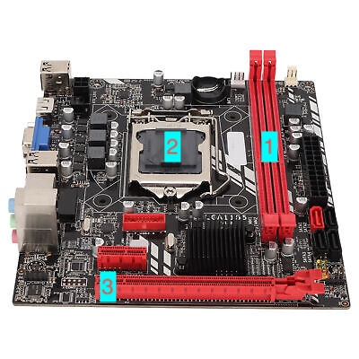

1. Put the I/O shield in the case if it’s not built into the motherboard, and place the motherboard in the computer case, lining up the motherboard with the standoffs and removing/adding standoffs as needed for different motherboard sizes. Screw the motherboard into the case.
2. If you have a GPU, put the GPU in the slot labeled 3 on the diagram above, ensuring that the necessary PCIe covers are removed. Make sure to screw the GPU into the case.
3. Place the Power Supply into the case, and connect the necessary cables. This will be the 24 pin cable to the motherboard, and the CPU power to the motherboard. If you have a GPU, it will likely need PCIe power.
4. If you have a SATA storage drive, securely mount the drive to somewhere on the case indicated by the case’s manual, and connect the drive to SATA power, along with SATA data to one of the SATA ports on the motherboard.
5. Install any necessary cooling fans into the computer case, and connect to the motherboards fan power.
6. Connect the computer to power and install your OS of choice.